1.Write a program to print the size of an int,float,a char and double type variable.

Ans.

#include<stdio.h>

#include<conio.h>

int main()

{

int intType;

float floatType;

double doubleType;

char charType;

printf("Size of int: %d bytes\n", sizeof(intType));

printf("Size of float:%d bytes\n", sizeof(floatType));

printf("Size of double: %d bytes\n", sizeof(doubleType));

printf("Size of char: %d byte\n", sizeof(charType));

getch();

}

Output:

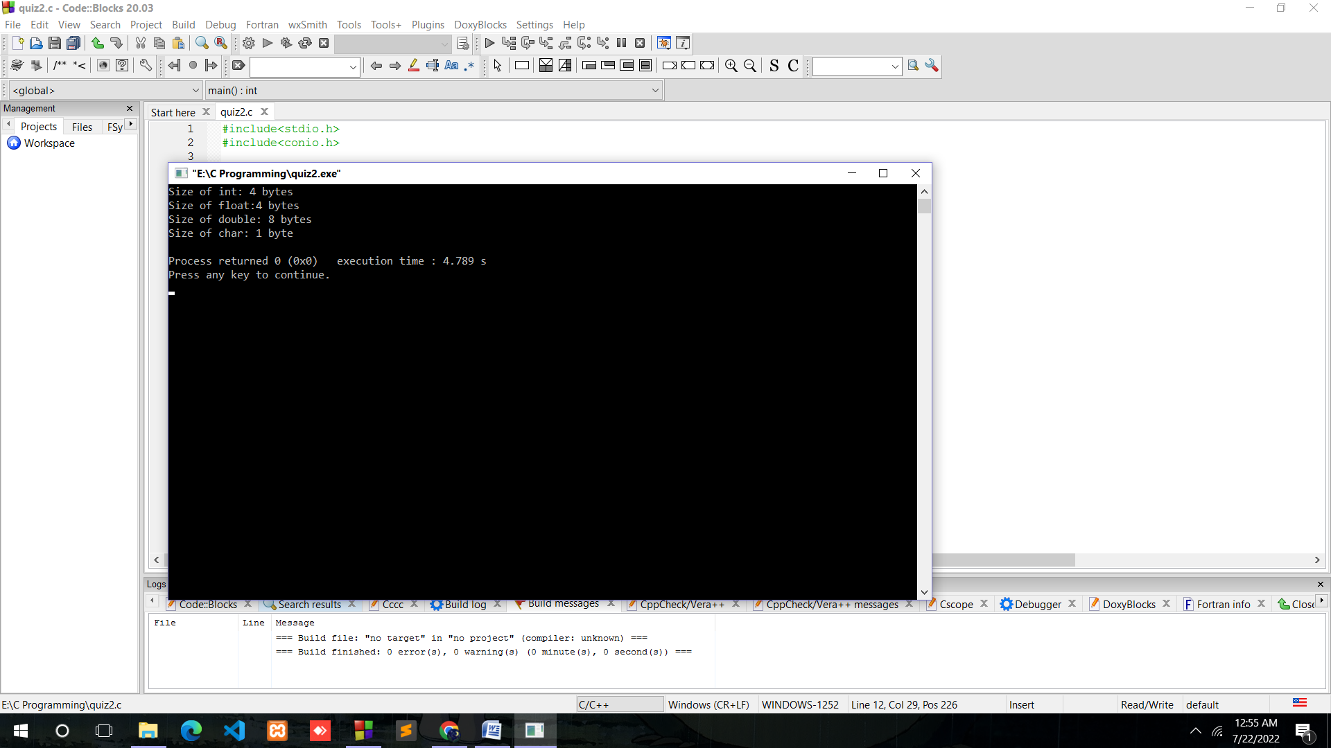

2.Write a program to find two last digit of a given number.

Ans.

#include<stdio.h>

#include<conio.h>

int main()

{

int m,n;

printf("Enter a number:");

scanf("%d",&m);

n= (m/1)%100;

printf("The middle digit is: %d",n);

getch();

}

Output:

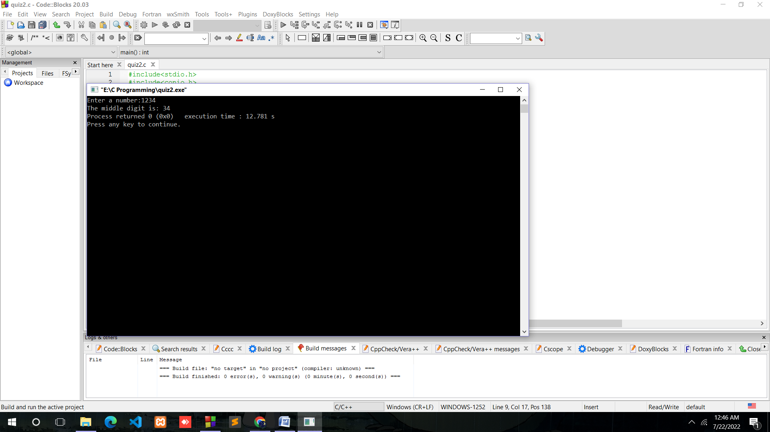

3.Write a program to find the first digit of a given three digit number.

Ans.

#include<stdio.h>

#include<conio.h>

int main()

{

int m,n;

printf("Enter a three digit number:");

scanf("%d",&m);

n= (m/100)%100;

printf("The middle digit is: %d",n);

getch();

}

Output:

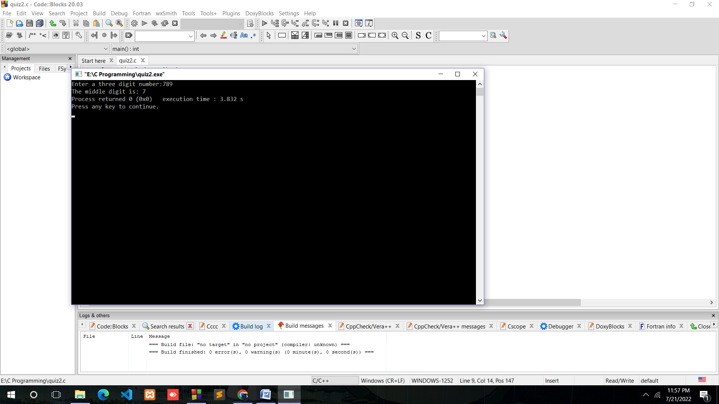

4.Write a program to find the middle digit of a given three digit number

Ans.

#include<stdio.h>

#include<conio.h>

int main()

{

int m,n;

printf("Enter a three digit number:");

scanf("%d",&m);

n= (m/10)%10;

printf("The middle digit is: %d",n);

getch();

}

Output:

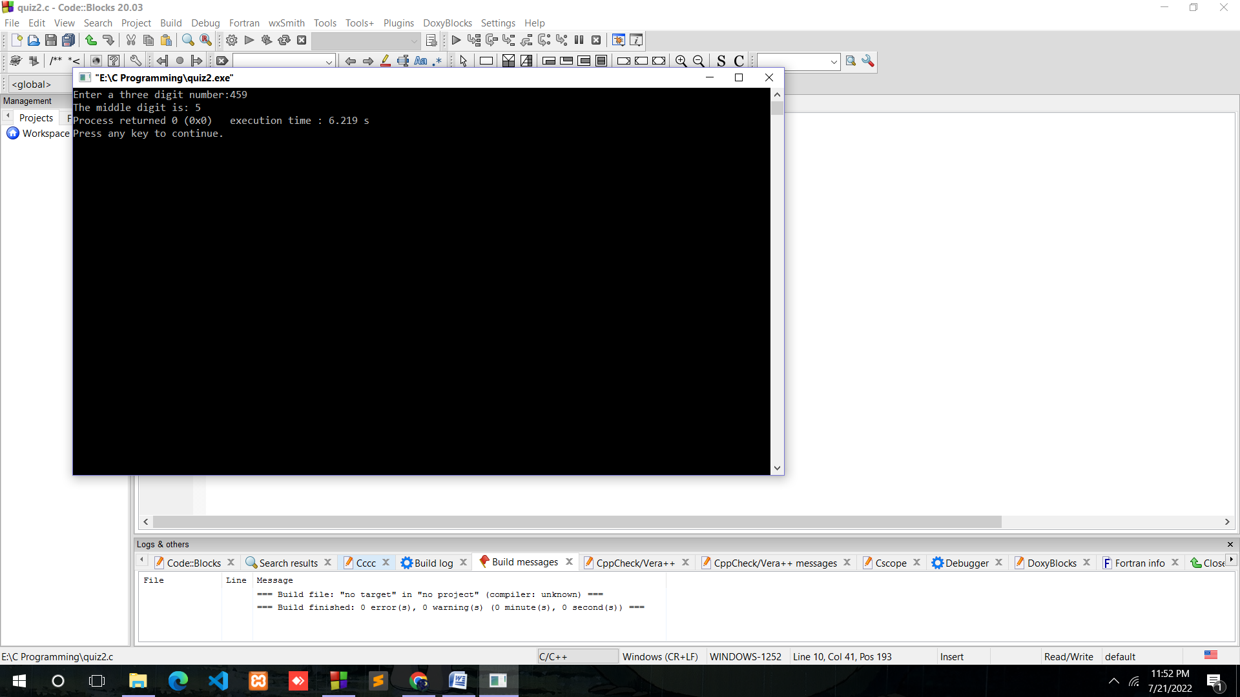

5.Write a program to swap two int variable

Ans.

#include<stdio.h>

#include<conio.h>

int main()

{

int a,b,c;

printf("Enter two numbers:");

scanf("%d %d",&a,&b);

c=a;

a=b;

b=c;

printf("After swapping %d %d",a,b);

getch();

}

Output:

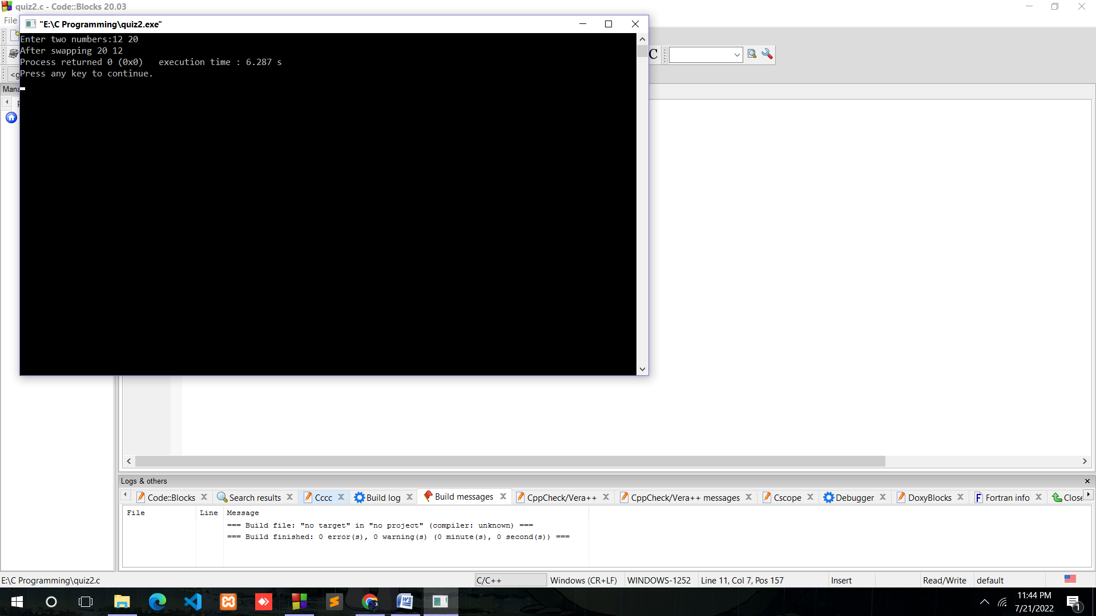

6.Write a program to swap two int variable without using any third variable.

Ans.

#include<stdio.h>

#include<conio.h>

int main()

{

int a,b;

printf("Enter two numbers:");

scanf("%d %d",&a,&b);

a=a+b;

b=a-b;

a=a-b;

printf("After swapping %d %d",a,b);

getch();

}

Output:

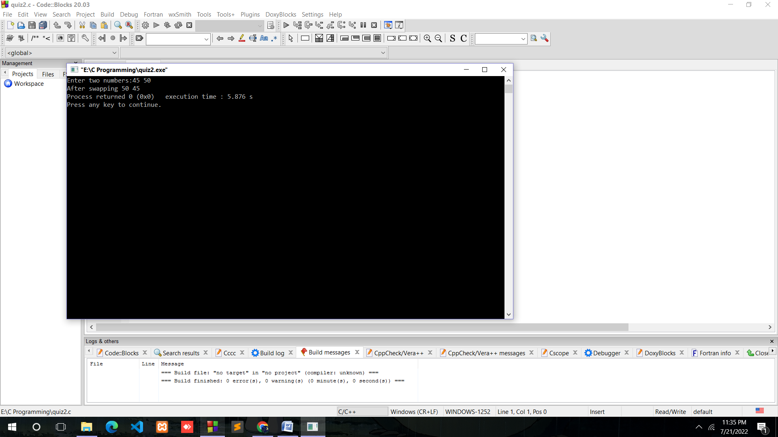

7.Write a program to make the last digit of a number stored in a variable as zero.(example. If x=2345 then make it x=2340).

Ans.

#include<stdio.h>

#include<conio.h>

int main()

{

int x,y,z;

printf("Enter a number X:");

scanf("%d",&x);

y=(x/1)%10;

if(y!=0){

z=x-y;

printf("a) %d",z);

}

else{

printf("b) %d",x);

}

getch();

}

Output:

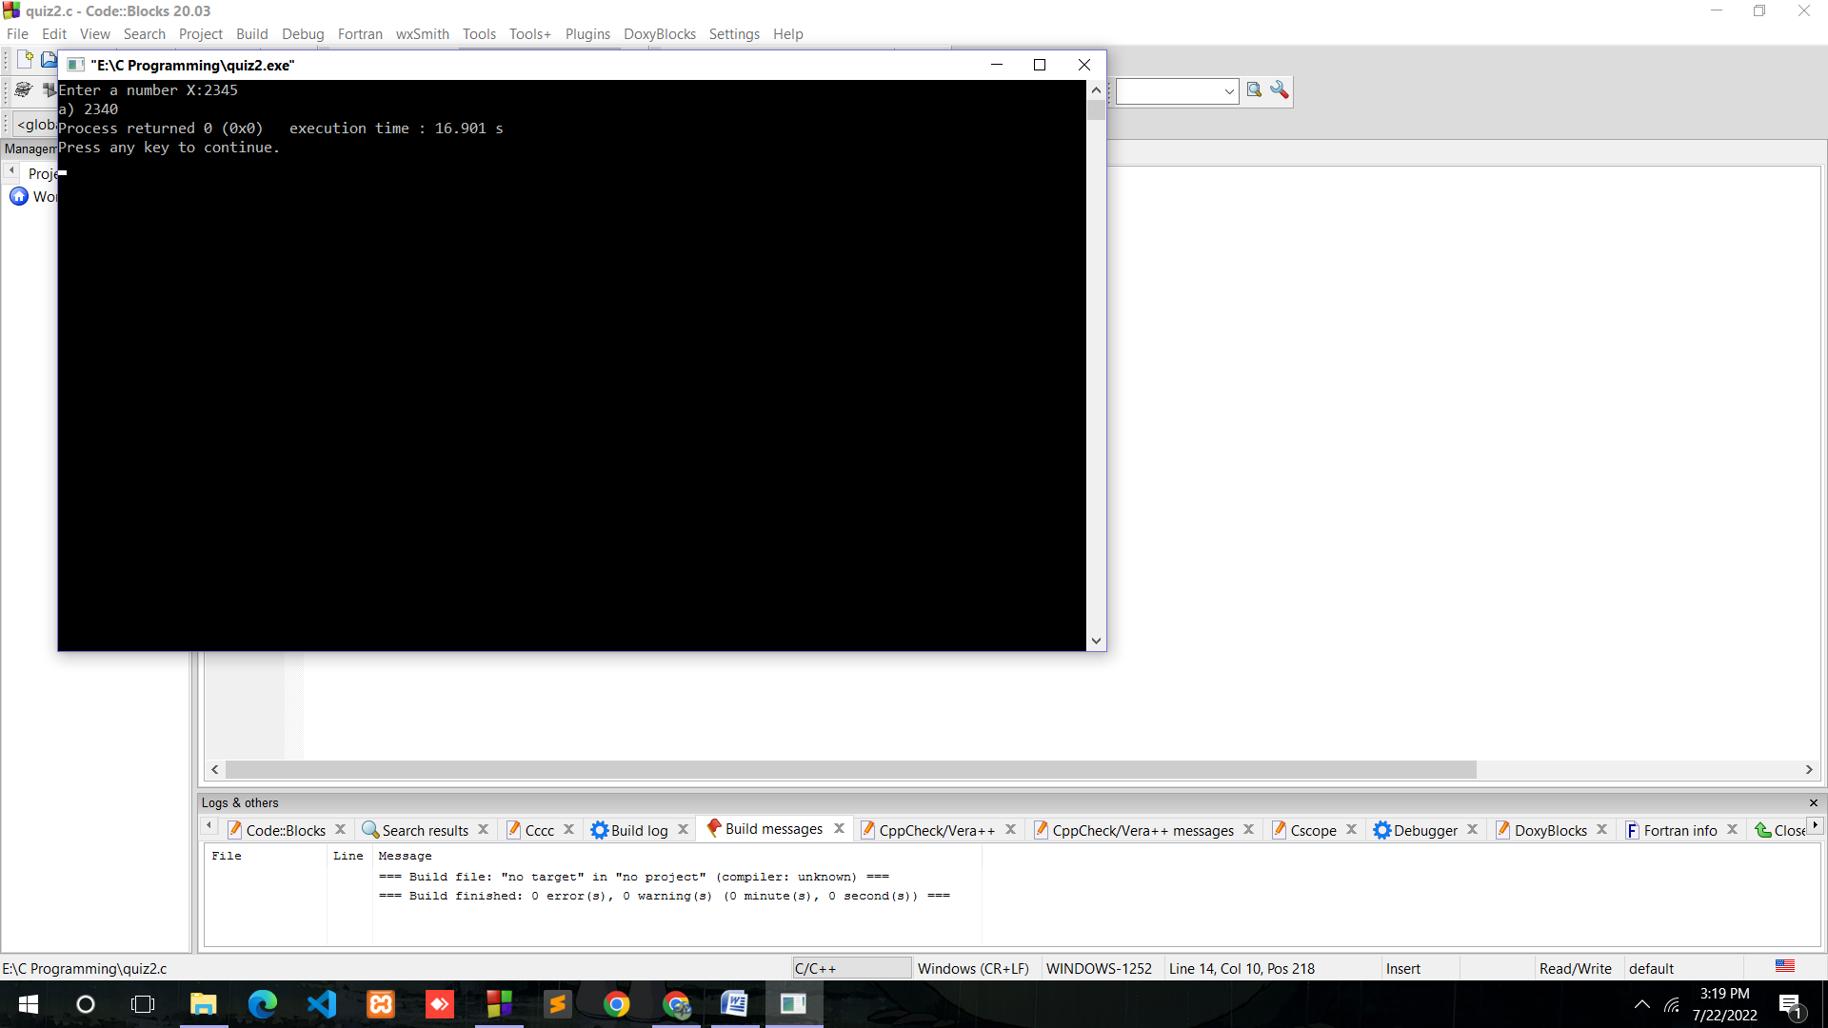

8.Write a program to input a number from the user and also input a digit. Append a digit in the number and print the resulting number.(Example. Number=234 and digit=9 then the resulting number is 2349).

Ans.

#include<stdio.h>

#include<conio.h>

int main()

{

int number,digit;

printf("Enter the number:");

scanf("%d",&number);

printf("Enter number to append:");

scanf("%d",&digit);

number= (number\*10)+digit;

printf("%d",number);

getch();

}

Output:

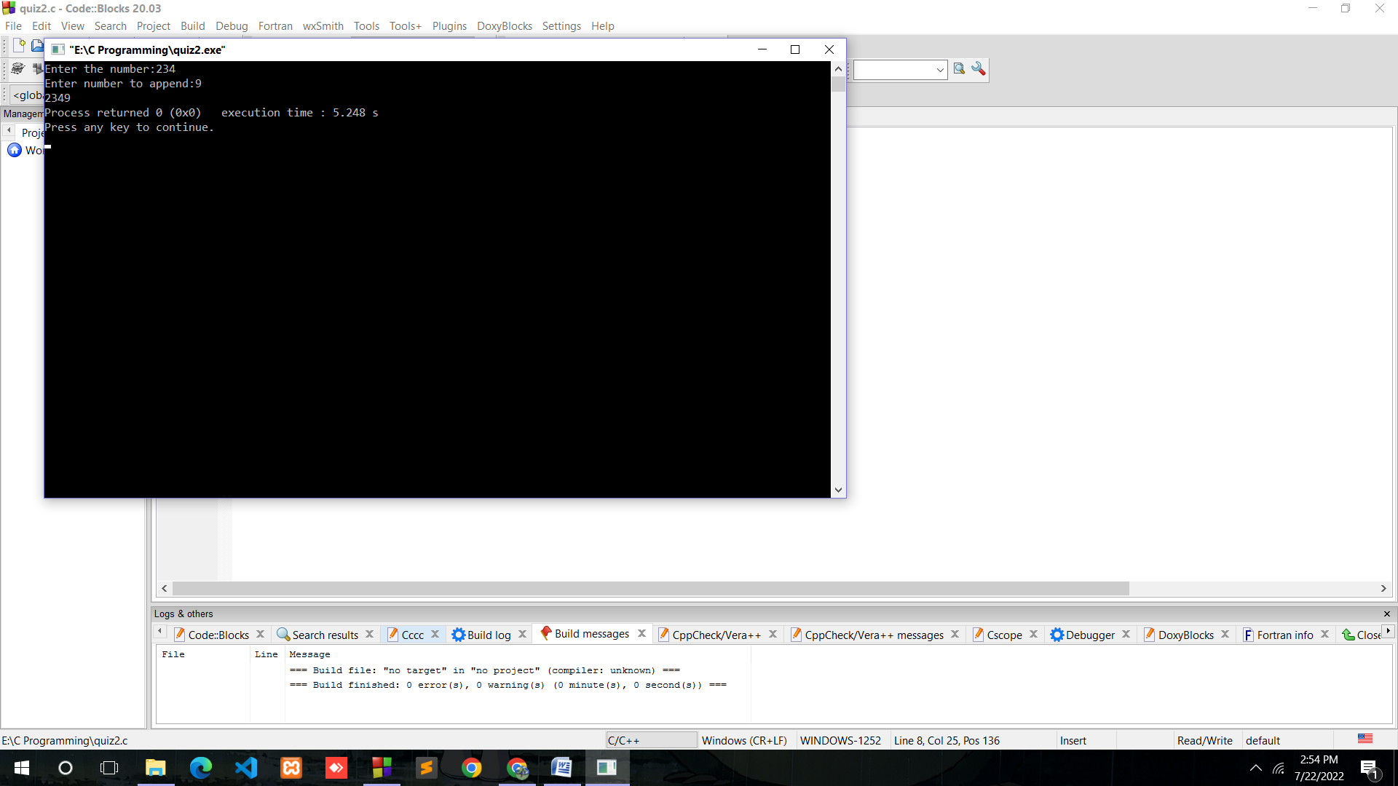

9.Assume price of of 1 USD is INR 76.23. Write a program to take amount in in INR and convert it into USD.

Ans.

#include<stdio.h>

#include<conio.h>

int main()

{

float rupees,dollar=76.23;

printf("Enter the amount for INR value:");

scanf("%f",&rupees);

dollar= rupees/dollar;

printf("The amount in USD is: %f",dollar);

getch();

}

Output:

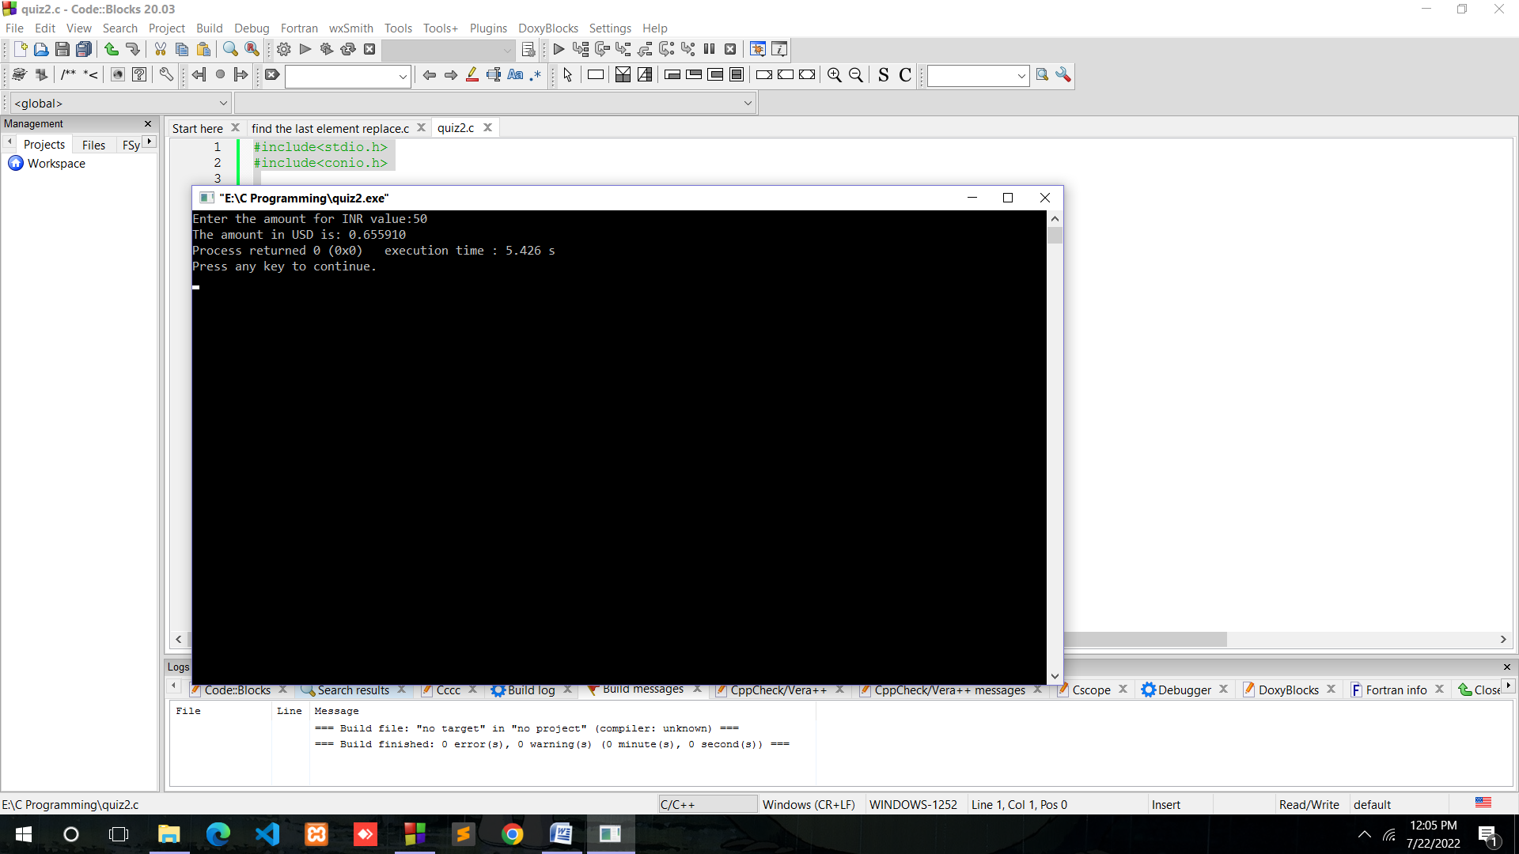

10.Write a program to take a three digit number from the user and rotate its digits by one position towards right.

Ans.

#include<stdio.h>

#include<conio.h>

int main()

{

int number,a,b,c;

printf("Enter a three digit number:");

scanf("%d",&number);

a=(number/1)%10;//last elements//

c=(number/10)%100;//first two elements//

b=a\*100;

a=b+c;

printf("%d",a);

getch();

}

Output:

